Design Document
Version <1.0>

CMPE 160: Introduction to Object Oriented Programming

SOFTWARE DESIGN DOCUMENT

PROJECT#2 “Simple Compiler”

INSTRUCTOR: LEVENT AKIN
STUDENT : EMİN ŞENAY
STUDENT ID : 2002103907
UNIVERSITY : BOĞAZİÇİ UNIVERSITY
YEAR : 2004/2nd TERM

Design Document

Introduction

Purpose
The purpose of this document is prepared to explain the “simple compiler” project, so that one who is interested in the program can easily understand the detailed design of the program. Also, people who want to modify the program can get the related information by this document.

Scope
The document is about “simple compiler” program which compiles programs with primitive language. The language has 5 commands, which are “INPUT, GOTO, PRINT, RUN and STOP”. There are 11 operators used by language, which are “+, -, *, /, ^, <, >, =, ~, |, &”. These commands have following usages:
INPUT: Defines a double variable. Variable names can only be the capital letters of the English Alphabet.
GOTO: It has a usage like following examples: “GOTO 03 ALWAYS” or “GOTO 25 IF A>B&C<D”. The number after GOTO statement is the line number which the program refers to the relative position of the line in the sequence of lines that were entered prior to the
RUN command. The first line number in this sequence is "00." ALWAYS means to go to the line specified immediately. IF means that to evaluate the infix expression after IF and to go to (or not) by the result of this evaluation.
PRINT: Prints the value of the variable.
RUN: Runs the program.
STOP: Terminates the program.

Definitions, Acronyms, and Abbreviations
The followings are used in the program:

class UsersProgram
The following functions are defined and used in this class:
UsersProgram(): Constructor
~UsersProgram(): Destructor
double getv (char &varletter): Gets variable from the variablename array.
void setv (char varletter, double number): Sets value to a variable.
char* getl (int linenum): Gets line from the lines array.
void setl (int linenum, const char* line): Saves the given line to the array.
int linesize (int linenum): Returns the line size of specified line number.
int checkFull (const char varletter): Controls if the variable is initialized before.

class Stack
The following functions are defined in this class:

Stack(int s): Constructor
~Stack(): Destructor
void push (const T& item): Push an element onto the stack
void pop (T& item): Delete and return the last element from the stack
void top (T& item): Only returns the last element of the stack
int isEmpty(): Checks the stack for being empty.

References
C How to Program, Deitel&Deitel, 3rd Edition
C++ Plus Data Structures, Nell Dale, 3rd Edition

Overview
This part of the document is explaining the purpose and the scope of this document, gives brief information about classes and gives the references. Second part of the document gives a detailed description of used classes with their diagrams. Lastly, third and the last part of the document give detailed information about functions used in the program with the flow diagram.

Internal Module Design

Class Diagrams
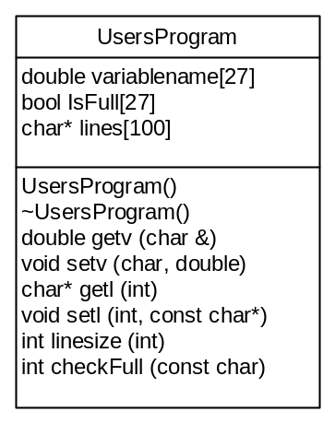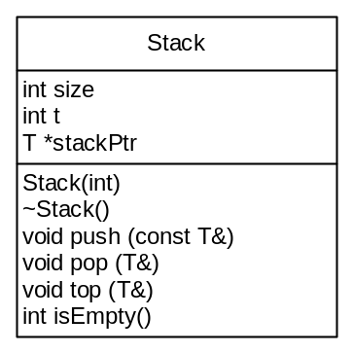

Class Descriptions
2.2.1 class <UsersProgram>
Class Decomposition
Inherited classes: None
Aggregated Classes: None
Associated Classes: None
Data members:
double variablename[27]
bool IsFull[27]
char* lines[100]
Member functions:
UsersProgram()
~UsersProgram()
double getv (char &varletter)
void setv (char varletter, double number)
char* getl (int linenum)
void setl (int linenum, const char* line)
int linesize (int linenum)
int checkFull (const char varletter)

Function Decomposition
Function Name: UsersProgram
Return Type: None
Input Parameter: None
Output Parameter: None
Files accessed: None
Files changed: None
Caller: UsersProgram();
Pre: None
Post: Class has been constructed
Algorithm: Initialize all elements of the IsFull array to 0.

Function Name: ~UsersProgram
Return Type: None
Input Parameter: None
Output Parameter: None
Files accessed: None
Files changed: None
Caller: ~UsersProgram();
Pre: Class must have been constructed.
Post: Class has been destructed.
Algorithm: Delete the lines array and its member character pointers.

Function Name: getvalue
Return Type: double
Input Parameter: char &varletter
Output Parameter: char &varletter
Files accessed: None
Files changed: None
Caller: double getv (char &varletter) ;
Pre: Class must have been constructed. Varletter must be between ‘A’ and ‘Z’.
Post: If the requested variable is initialized before, value of the requested variable is returned. Else, ‘!’ is returned.
Algorithm: If varletter is not initialized, change varletter to ‘!’. Return the value of the variable.

Function Name: setvalue
Return Type: None
Input Parameter: char varletter, double number
Output Parameter: None
Files accessed: None
Files changed: None
Caller: void setv (char varletter, double number);
Pre: Class must have been constructed. Varletter must be between ‘A’ and ‘Z’. Number must be a double.
Post: The given value of the given variable is saved.
Algorithm: The place of the variable name on the variablename array (‘A’=variablename[1], ‘B’=variablename[2]…) is equal to number. Change appropriate element of IsFull array to 1.

Function Name: getl
Return Type: char*
Input Parameter: int linenum
Output Parameter: None
Files accessed: None
Files changed: None
Caller: char* getl (int linenum)
Pre: Class must have been constructed. Linenum must be between 0 and 100.
Post: Requested line of the lines array returned.
Algorithm: return lines[linenum];

Function Name: setl
Return Type: None
Input Parameter: int linenum, const char* line
Output Parameter: None
Files accessed: None
Files changed: None
Caller: void setl (int linenum, const char* line);
Pre: Class must have been constructed. Linenum must be between 0 and 100. Same linenum must not be used more than once.
Post: Given string is saved to the lines array.
Algorithm: Find length of the given string and allocate that much of char to the appropriate place of the lines array. Copy the given string to the array.

Function Name: linesize
Return Type: int
Input Parameter: int linenum
Output Parameter: None
Files accessed: None
Files changed: None
Caller: int linesize (int linenum)
Pre: Class must have been constructed. Uninitialized lines must not be requested.
Post: The size of the requested line returned.
Algorithm: Return the string length of lines[linenum].

Function Name:
Return Type: int
Input Parameter: const char varletter
Output Parameter: None
Files accessed: None
Files changed: None
Caller: int checkFull (const char varletter);
Pre: Class must have been constructed.
Post: Client knows if varletter is used before.
Algorithm: if the place of the varletter on the IsFull array is 0, return 0. Else, return 1.

2.2.2 template <class T>
class <Stack>
Class Decomposition
Inherited classes: None
Aggregated Classes: None
Associated Classes: None
Data members:
int size
int t
T *stackPtr
Member functions:
Stack(int s)
~Stack()
void push (const T& item)
void pop (T& item)
void top (T& item)
int isEmpty();

Function Decomposition

Function Name: Stack(int s)
Return Type: None
Input Parameter: int s
Output Parameter: None
Files accessed: None
Files changed: None
Caller: Stack(int s)
Pre:
Post: Class must have been constructed.
Algorithm: s is equal to 1; t is equal to -1. Allocate stackPtr with T[size] elements.

Function Name: ~Stack()
Return Type: None
Input Parameter: None
Output Parameter: None
Files accessed: None
Files changed: None
Caller: ~Stack()
Pre: Class must have been constructed.
Post: Class is destructed.
Algorithm: Delete stackPtr dynamic array.

Function Name: push
Return Type: None
Input Parameter: const T& item
Output Parameter: None
Files accessed: None
Files changed: None
Caller: void push (const T& item);
Pre: Class must have been constructed. Stack must not be full.
Post: Given element is pushed to the Stack.
Algorithm: stackPtr[t] is equal to item. Increment t (Top).

Function Name: void pop (T& item);
Return Type: None
Input Parameter: None
Output Parameter: T& item
Files accessed: None
Files changed: None
Caller: void pop (T& item);
Pre: Class must have been constructed. Stack must not be empty.
Post: Item is equal to the last element of the stack and the last element of the stack is deleted.
Algorithm: item is equal to stackPtr[t]. Decrement t.

Function Name: void top (T& item);
Return Type: None
Input Parameter: None
Output Parameter: T& item
Files accessed: None
Files changed: None
Caller: void top (T& item);
Pre: Class must have been constructed. Stack must not be empty.
Post: Item is equal to the last element of stack.
Algorithm: item is equal to stackPtr[t].

Function Name: isEmpty()
Return Type: int
Input Parameter: None
Output Parameter: None
Files accessed: None
Files changed: None
Caller: int isEmpty();
Pre: Class must have been constructed.
Post: Client knows whether stack is empty or not
Algorithm: if t is equal to -1, return 1. Else, return 0.

3. Flow Diagram

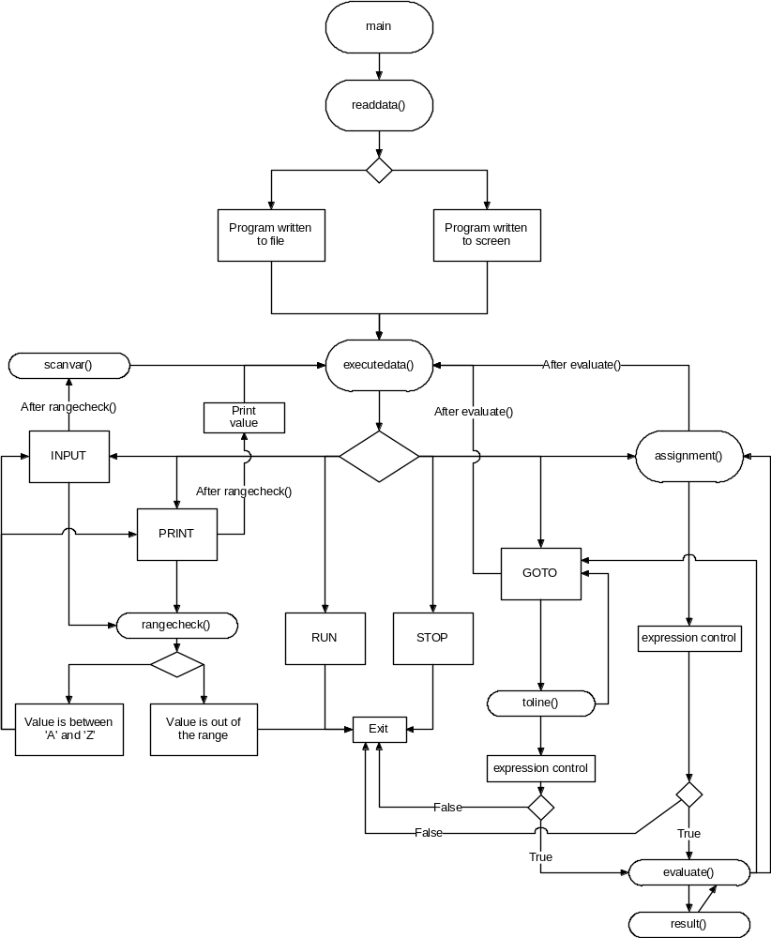

Function Name: main
Return Type: None
Input Parameter: None
Output Parameter: None
Files accessed: None
Files changed: None
Caller: void main();
Pre: None
Post: Program has ended.
Algorithm: Call readdata and executedata functions.

Function Name: readdata
Return Type: None
Input Parameter: None
Output Parameter: None
Files accessed: “input.txt”
Files changed: None
Caller: void readdata();
Pre: None
Post: Lines of the code has been saved to code.usersprogram class.
Algorithm: Ask the user from where does the compiler reads data from. If from file, open “input.txt” and read and save the data until reading RUN command. If from screen, print line numbers and read the data line by line and save them again until reading RUN command.

Function Name: executedata
Return Type: None
Input Parameter: None
Output Parameter: None
Files accessed: None
Files changed: None
Caller: void executedata();
Pre: UsersProgram.code class must be initialized. Code of the user must be read and saved.
Post: The data is executed and compiler program has terminated.
Algorithm: Get the code line by line. If line contains INPUT command, check the variable name by rangecheck function. If variable is in the range, read the value of the variable by scanvar function. Else, quit. If the line contains PRINT command, check the variable name by rangecheck function. If variable is in the range and if the variable was initialized before, print the value of the variable. Else, quit. If the line contains GOTO, call toline function. If the function returns -1, don’t change the line number. Else, change the line number with the value toline function returned. If the line contains an expression with an assignment, call assignment function. If the line contains RUN or STOP, quit the program. If the line contains none of them, print an error and quit the program.

Function Name: scanvar
Return Type: None
Input Parameter: const char input
Output Parameter: None
Files accessed: None
Files changed: None
Caller: void scanvar(const char input);
Pre: UsersProgram.code class must be initialized.
Post: Value of the variable (passed by const char input) is saved.
Algorithm: Take the value from the screen and set it to variable by setv function.

Function Name: toline
Return Type: int
Input Parameter: char* line, int linenumber
Output Parameter: None
Files accessed: None
Files changed: None
Caller: int toline(char *line, int linenumber);
Pre: None
Post: The expression is evaluated. If the value of the expression is true, linenumber; else -1 returned.
Algorithm: Control the expression with these rules:
- First element of the expression can only be a variable or ‘~’ operator.
- Last element of the expression can only be a variable.
- Two variables can not be next to each other.
- Two operators, except ‘~’ can not be next to each other.
- All the variables in the expression must be initialized before.
- Expression can not contain any character except the capital letters of the English alphabet and valid operators.
- After ‘~’ operator, there can not be any operator. Also, there can only be ‘|’ or ‘&’ operators before ‘~’ operator.
If the expression obeys all of these rules, pass the expression to evaluate function. If the evaluate function returns 1, return linenumber; else return -1. If the expression does not obey any of these rules, display an error message containing the reason of the error and terminate the program.

Function Name: assignment
Return Type: None
Input Parameter: char* line, int linenumber
Output Parameter: None
Files accessed: None
Files changed: None
Caller: void assignment(char* line, int linenumber);
Pre: UsersProgram.code class must be initialized.
Post: The result value is assigned to the variable.
Algorithm: Control the expression with these rules:
- First element of the expression can only be a variable.
- Second element of the expression can only be ‘=’ sign.
- Last element of the expression can only be a variable.
- Values of the all variables, except the variable in the left hand side, must be initialized before.
- Two variables and two operators can not be next to each other.
- Expression can not contain any character except the capital letters of the English alphabet and valid operators.
If the expression obeys all of these rules, pass the expression to evaluate function. Take the returned result and set to the variable in the left hand side. If the expression does not obey any of these rules, display an error message containing the reason of the error and terminate the program.

Function Name: rangecheck
Return Type: None
Input Parameter: char letter, int ln
Output Parameter: None
Files accessed: None
Files changed: None
Caller: void rangecheck(char letter, int ln);
Pre: None
Post: Given char is checked
Algorithm: if letter is not between ‘A’ and ‘Z’, give an error message and terminate.

Function Name: evaluate
Return Type: None
Input Parameter: None
Output Parameter: None
Files accessed: None
Files changed: None
Caller: double evaluate (char* expression, char* op, int* preced)
Pre: Expression must be valid.
Post: The expression is evaluated.
Algorithm: Read the expression character by character. If the character is a variable, push the value of the variable to the values stack. If the character is an operator and the operators stack is empty, push the operator to the operators stack. If the operators stack is not empty, top the operators stack and find two operators’ precedences. If the operator in the stack has a lower precedence or both of the operators are '^', push the operator to the operators stack. If the operator in the stack has a higher precedence or operators’ precedences are equal and they are different than ‘^’ do the following: Pop an element from the values stack and operators stack. If popped operator is different than ‘~’, pop another element from the values stack (‘~’ takes only one value). Evaluate the result by result function and push the result to the values stack. If all of the expression has evaluated, there must be only one element in the values stack. Return this value.

Function Name: rangecheck
Return Type: double
Input Parameter: double FirstValue, char op, double SecondValue
Output Parameter: None
Files accessed: None
Files changed: None
Caller: double result(double FirstValue, char op, double SecondValue);
Pre: None.
Post: Result is returned.
Algorithm: Switch char op.
- ‘|’: If FirstValue or SecondValue is 1, return 1. Else, return 0.
- ‘&’: If FirstValue and SecondValue is 1, return 1. Else, return 0.
- ‘~’: If SecondValue is 0, return 1. Else, return 0.
- ‘<’: If FirstValue is smaller than SecondValue, return 1. Else, return 0.
- ‘>’: If FirstValue is larger than SecondValue, return 1. Else, return 0.
- ‘=’: If FirstValue is equal to SecondValue, return 1. Else, return 0.
- ‘+’: Return the sum of two variables.
- ‘-‘: Return FirstValue-SecondValue.
- ‘*’: Return the multiplication of two values.
- ‘/’: Return FirstValue/SecondValue.
- ‘^’: Return Firstvalue^{SecondValue}.
- Default: (There is no need of this, because there can not be any errors. (char op is controlled in the caller functions of this function).) Display an error message and terminate.

